How (and why) do I “hide” sections from my learners?
When you understand how to use Moodle and its benefits to your learners, you may find yourself uploading numerous links and activities. Now this could be very confusing to your learners – would you deliver all of your course content on the first session? Also, if you are working on the weekly format and uploading your supporting session documents and power-points, you may not want your learners to see them too far in advance – now, this is where the “hide” button is useful.
You can choose to hide single links or complete sections of your page.
Ensure editing is on (remember press the green button). To the right of your link, you will see a button “edit”. Press the down arrow. This will bring up a drop down menu – can you see the “eye”. Press this, the eye will appear with a strike through it and this link will disappear from your learner’s Moodle page. Please note that you will be able to see it but it will appear a lighter shade.
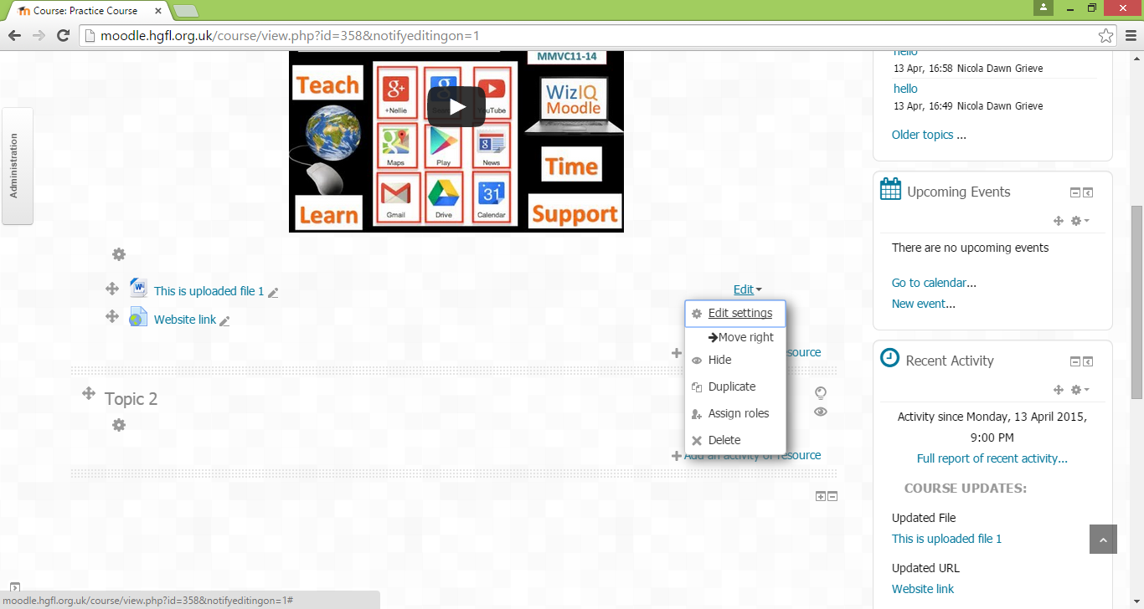

To hide a whole section, click on the “eye” to the right of that section. Again the eye will appear with a strike through it and the section disappears from your learner’s Moodle page.
Ready for your learners to view the information? – simply click on the eye symbol again – the strike will disappear and your learners will have full access to the link or section.

